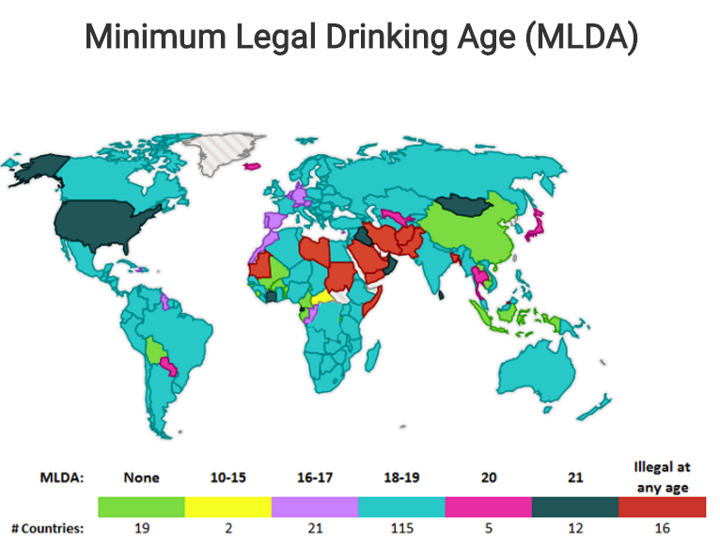
I. Minimum Legal Drinking Ages in 190 Countries (categorized by lowest legal age minimum for any type of alcohol or purchase)
No MLDA (19 countries)
Benin, Bolivia, Burkina Faso, Burundi, Cambodia, Cameroon, China, Gabon, Guinea-Bissau, Indonesia, Kosovo, Laos, Mali, Rwanda, Sao Tome and Principe, Sierra Leone, Solomon Islands, Timor-Leste, Togo
10-15 MLDA (2 countries)
Antigua and Barbuda, Central African Republic
16-17 MLDA (21 countries)
Austria, Belgium, Congo, Cyprus, Denmark, Dominica, Germany, Grenada, Guyana, Haiti, Liechtenstein, Luxembourg, Malta, Morocco, Netherlands, Portugal, Saint Lucia, Saint Vincent and the Grenadines, San Marino, Spain, Switzerland
18-19 MLDA (115 countries)
Albania, Algeria, Andorra, Angola, Argentina, Armenia, Australia, Azerbaijan, Bahamas, Barbados, Belarus, Belize, Bhutan, Bosnia and Herzegovina, Botswana, Brazil, Bulgaria, Canada, Cape Verde, Chad, Chile, Colombia, Comoros, Costa Rica, Croatia, Cuba, Czech Republic, Democratic Republic of the Congo, Dominican Republic, Ecuador, Egypt, El Salvador, Eritrea, Estonia, Ethiopia, Fiji, Finland, France, Gambia, Georgia, Ghana, Greece, Guatemala, Guinea, Honduras, Hungary, India, Ireland, Israel, Italy, Jamaica, Jordan, Kazakhstan, Kenya, Kyrgyzstan, Latvia, Lesotho, Liberia, Lithuania, Macedonia, Madagascar, Malawi, Malaysia, Mauritius, Mexico, Moldova, Monaco, Montenegro, Mozambique, Myanmar, Namibia, Nepal, New Zealand, Nicaragua, Niger, Nigeria, Norway, Panama, Papua New Guinea, Peru, Philippines, Poland, Romania, Russia, Saint Kitts and Nevis, Senegal, Serbia, Seychelles, Singapore, Slovakia, Slovenia, South Africa, South Korea, Suriname, Swaziland, Sweden, Syria, Tajikistan, Tanzania, Tonga, Trinidad and Tobago, Tunisia, Turkey, Turkmenistan, Tuvalu, Uganda, Ukraine, United Kingdom, Uruguay, Vanuatu, Vatican City, Venezuela, Vietnam, Zambia, Zimbabwe
20 MLDA (5 countries)
Iceland, Japan, Paraguay, Thailand, Uzbekistan
21 MLDA (12 countries)
Côte d'Ivoire, Equatorial Guinea, Iraq, Kiribati, Micronesia, Mongolia, Nauru, Oman, Palau, Samoa, Sri Lanka, United States
Illegal to drink alcohol at any age (16 countries) some exceptions for non-Muslims may apply
Afghanistan, Bahrain, Bangladesh, Brunei Darussalam, Iran, Kuwait, Libya, Maldives, Mauritania, Pakistan, Qatar, Saudi Arabia, Somalia, Sudan, United Arab Emirates, Yemen

